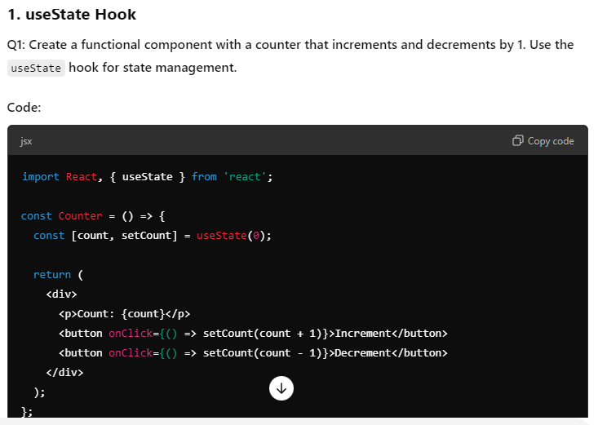

**2. useEffect Hook**

**Q2: Create a component that fetches user data from an API and displays the user's name. Use the useEffect hook to fetch data on component mount.**

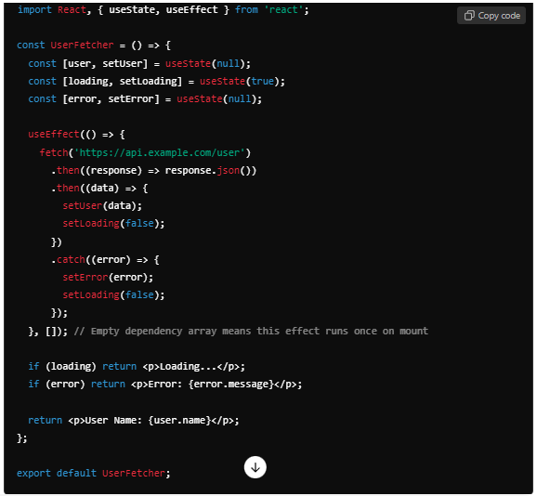

### ****3. useReducer Hook****

**Q3: Implement a simple todo list application using useReducer to manage the list state. Implement add and remove functionalities.**

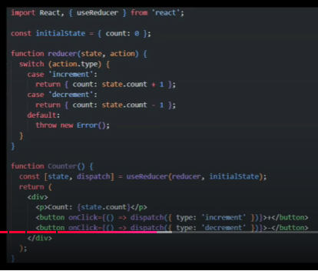

### ****4. useMemo Hook****

**Q4: Create a component that calculates the factorial of a number using useMemo to optimize performance.**

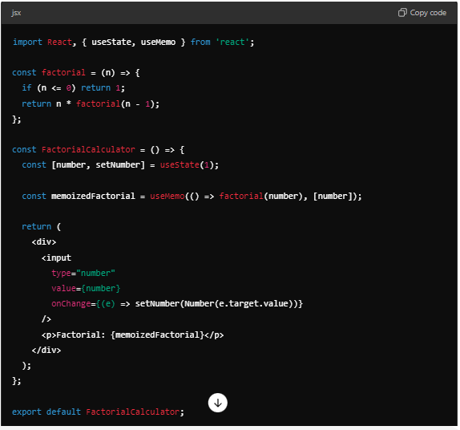

### ****5. useCallback Hook****

**Q5: Create a component with a button that increments a counter and another button that prints the current counter value. Use useCallback to memoize the print function.**

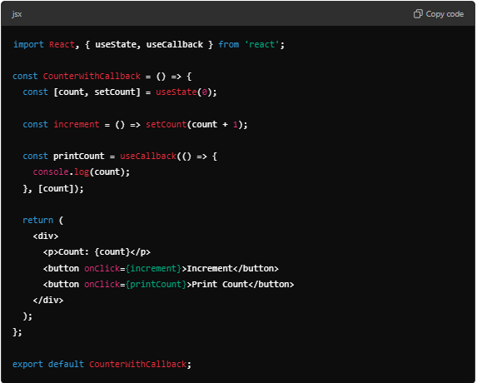

### ****6. Custom Hook****

**Q6: Create a custom hook useLocalStorage that synchronizes state with localStorage. Use this hook in a component to manage a counter value.**

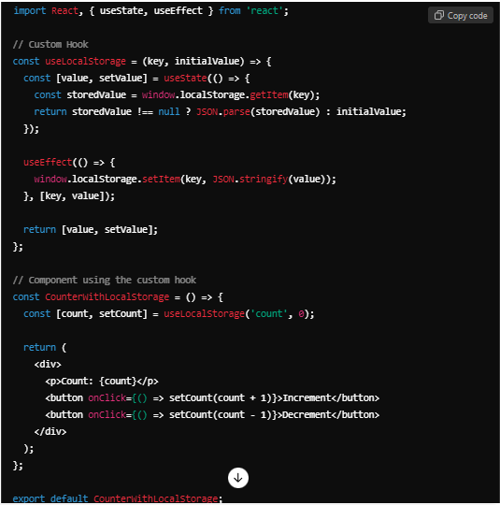

### ****7. useContext Hook****

**Q7: Create a ThemeContext to provide a theme value and a function to toggle between light and dark themes. Use useContext to consume the theme value in a component.**

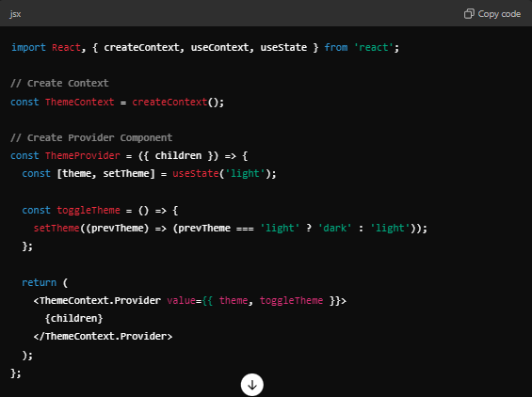

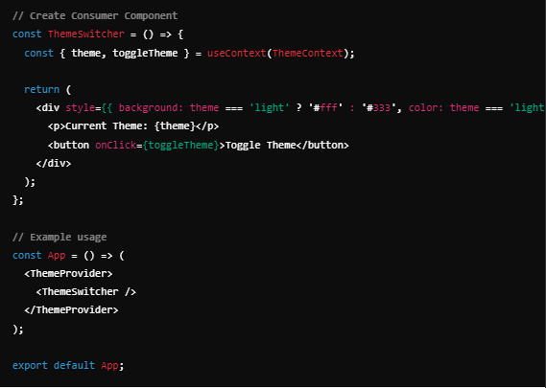

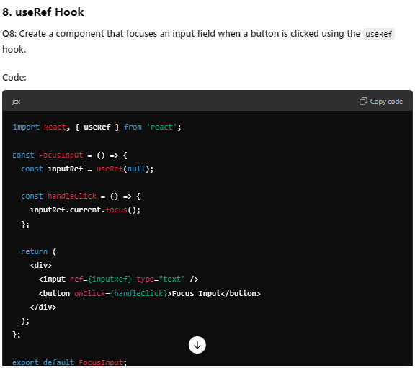

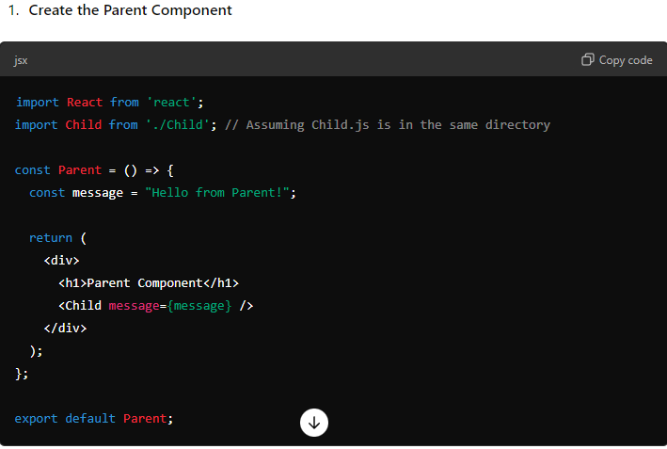

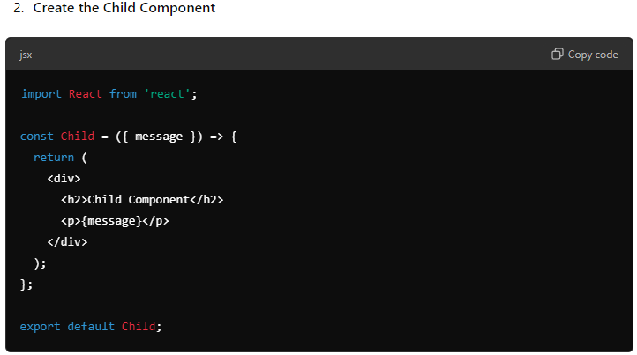

3. Toggle button using React

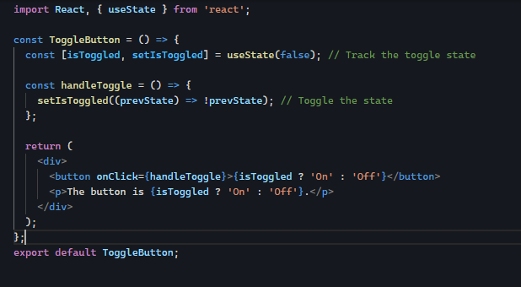

4. Textbox Binding

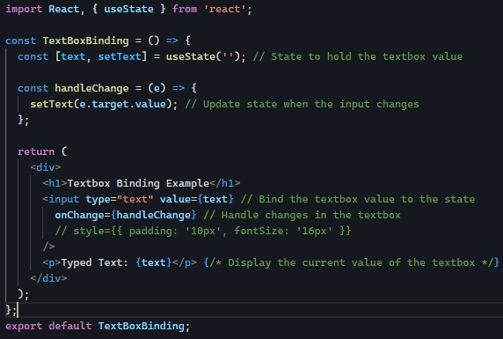

4. Timer in React

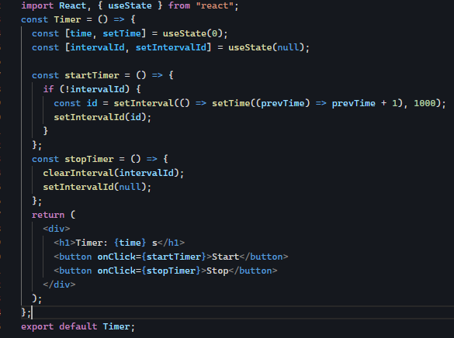

5. Timer with useEffect

